June is National Pet Preparedness Month! Use the following posts for your clinic’s social media to raise awareness.

June is National Pet Preparedness Month. Just like you should have a plan for your family in case of an emergency, you should also plan for your pet. Leaving pets behind could lead to them getting lost, injured, or worse. We’ll be posting all month about how you can plan for your pet – stay tuned! #PetPreparednessMonth

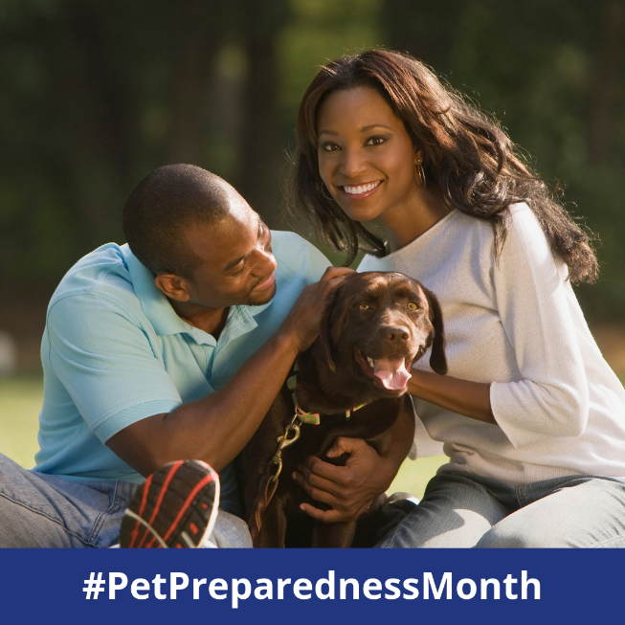

If you live in an area where natural disasters typically occur, or even if you don’t, the time to create a plan for your pet is now. Here are three things you should do sooner rather than later: (1) create a buddy system with a trusted neighbor in case you’re not home, (2) identify pet-friendly hotels along your evacuation route, and (3) call us about getting your pet microchipped if they aren’t already. #PetPreparednessMonth

Building a Pet Emergency Preparedness Kit will ensure that you have everything you need in case you would need to evacuate with your pet. Download FEMA’s list to ensure you’ve thought of everything you could need. https://www.fema.gov/media-library-data/1390846777239-dc08e309debe561d866b05ac84daf1ee/pets_2014.pdf #PetPreparednessMonth

OR

Building a Pet Emergency Preparedness Kit will ensure that you have everything you need in case you would need to evacuate with your pet. Stop by our office for a free print-out of what we’d recommend you get and we’ll get you started with a free first aid kit and print-outs of your pet’s emergency records. #PetPreparednessMonth

[Download our checklist here that you can print out for this!]

Check out this video by FEMA on how to be proactive with your pet emergency preparedness: https://www.youtube.com/watch?v=aUbSF_S20bE #PetPreparednessMonth

Practice makes perfect – so practice your evacuation plan with your pets! You want to make sure pets feel comfortable with their carrier and with being in your vehicle. #PetPreparednessMonth

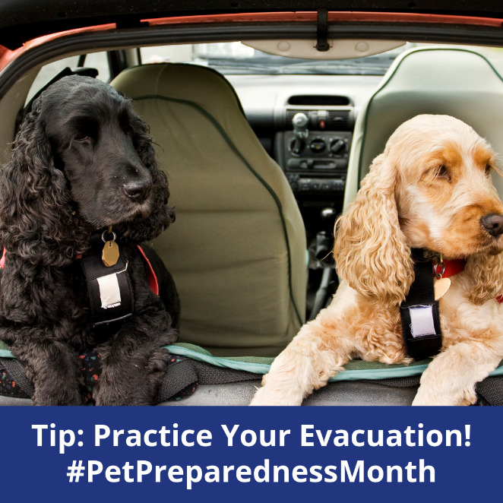

Animals left behind in a disaster can easily be lost or injured. Make sure you’re prepared to take your pets with you in case of an emergency! Create a buddy system with your neighbors in case you’re not home when evacuation is needed. #PetPreparednessMonth

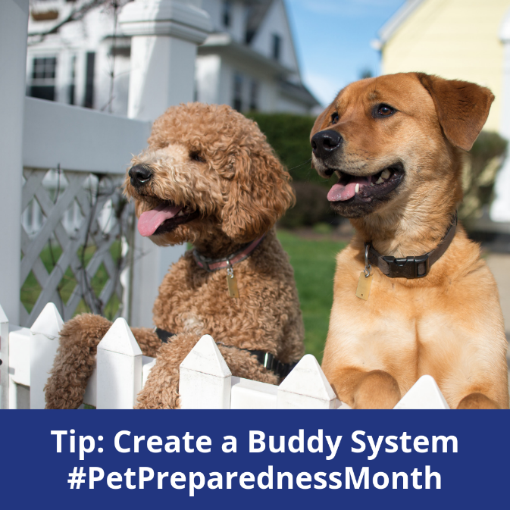

We know you take a lot of cute selfies with your pets – print one out and keep it in your emergency kit in case you ever need to prove ownership! #PetPreparednessMonth

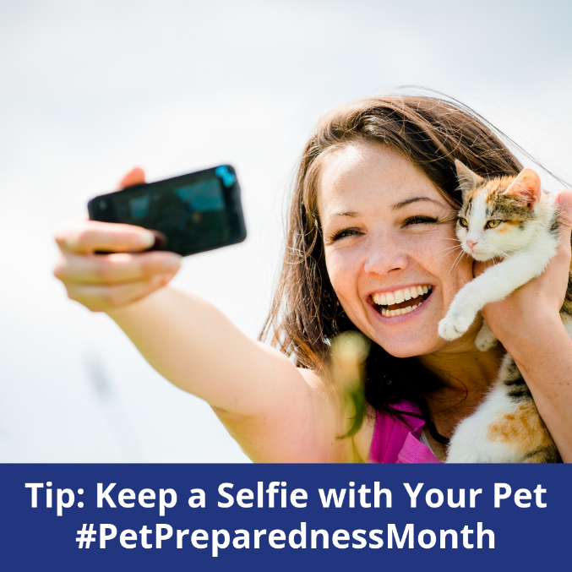

Microchipping your pets increases your chance of being reunited if you’re ever separated during an emergency. If your pet is not microchipped – call us today to set up an appointment! If your pet is microchipped, make sure your microchip registration info is up to date. #PetPreparednessMonth

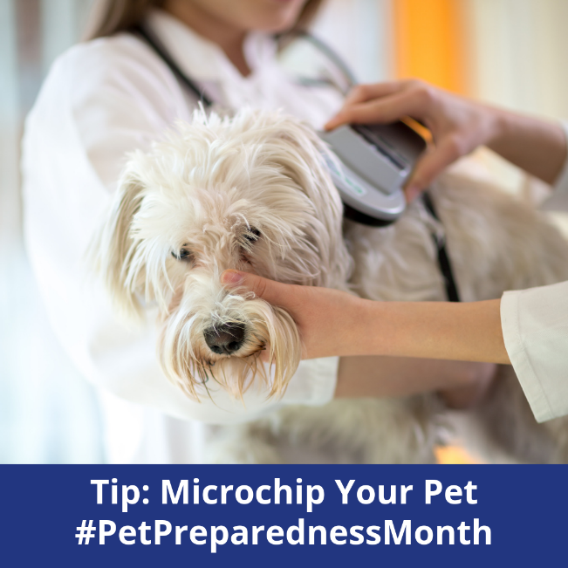

Your pet should always have ID on them. Make sure your name and contact information are on your pet’s ID tag in case you get separated. Bonus tip: include the phone number of an out of town relative, just in case! #PetPreparednessMonth

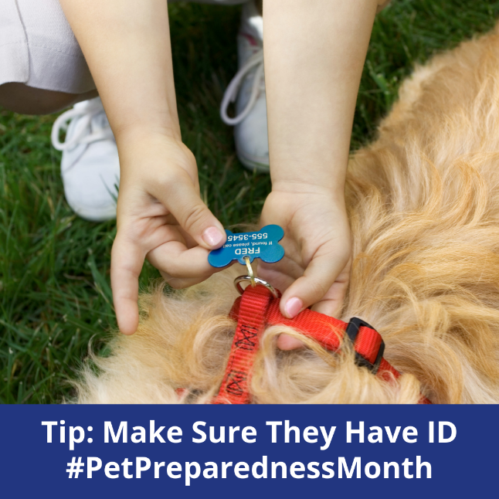

Once you know your evacuation route, locate a veterinarian or animal hospital at your destination in case your pet should need medical attention. Be prepared by having printouts of your pet’s medical records handy when you arrive. #PetPreparednessMonth
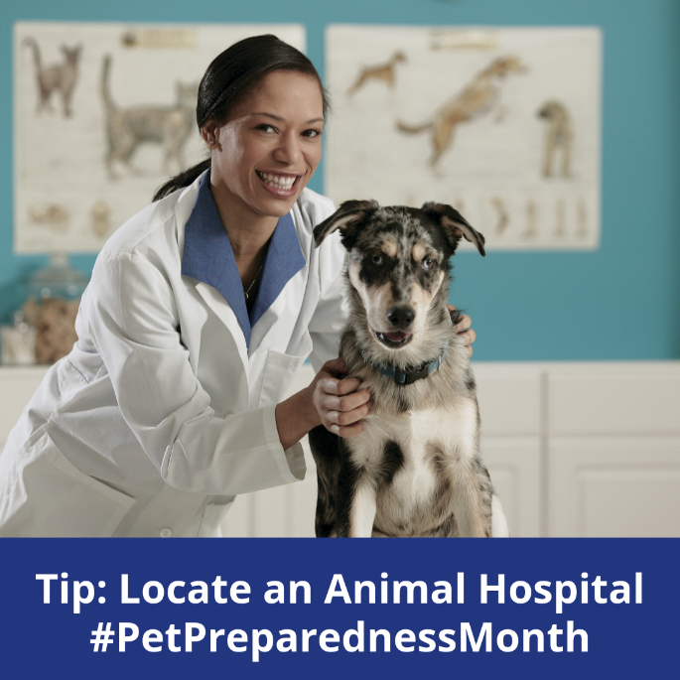

How much food and water should you have in your Pet Emergency Preparedness Kit? We recommend at least a three day supply. Don’t forget to throw in some treats as well! #PetPreparednessMonth

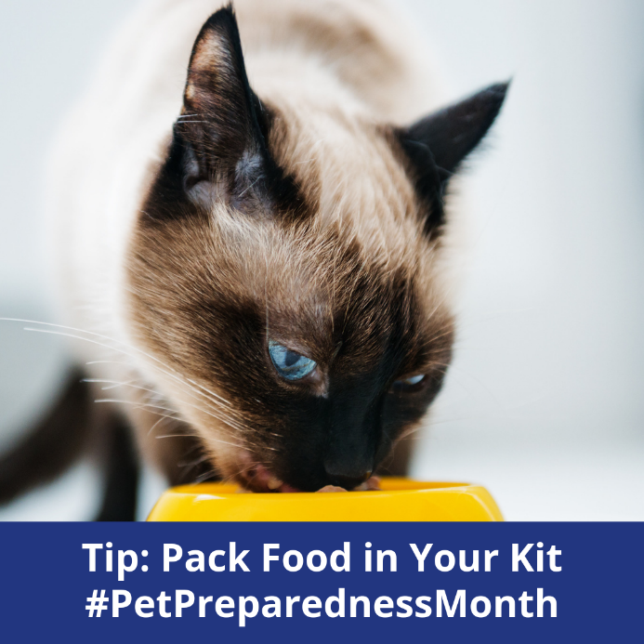

If you have questions on how to prepare for an emergency – we’re here for you! Leave a comment below, send us a message, or give us call. Your pet’s safety is our #1 priority! #PetPreparednessMonth

